iOS Dev Midterms Set A

Second Term SY 2014-15 Ronald L. Ramos

Name: ___________________________________

Student Number: __________________________

Course:__________________________________

Answer the following questions as best as you can. Save the file as “iOSDev Midterms 1st Term SY2014-15 – yourfullname.doc”

When done upload the document to your wikifolder and update your wiki page.

The following will merit an automatic zero in the exam:

1. Plagiarizing answers

2. Copying from a classmate/seatmate

3. Opening facebook or any form of social media

4. Talking to a classmate/seatmate during the exam

Open notes. Open Internet. Closed Social Media sites.

Good luck! God speed!

The test is good for 100 points but it is possible to go beyond 100 points.

1. Based on the picture below answer to the best of your ability: (40 points total)

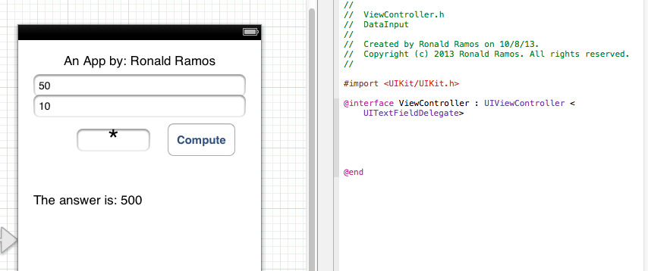

1. How many controls are visible (10 points)?
2. How many label controls are there (10 points)?
3. What code should appear in between @interface and @end? (20 points, Paste the code below)

2. Given the picture below answer the succeeding questions to the best of your knowledge: (30 points)

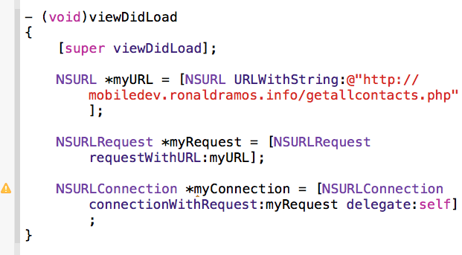

1. What file is this piece of code found in? __________
2. Based on what you know about Xcode which variable is declared but not used? __________
3. What object knows what website the app will connect to? __________
4. What 3 object types are created based on the code above? _________
5. What website does this app connect to? ________
6. What four methods are associated with the NSURLConnection object?

3. Given the screenshot below (15 points):

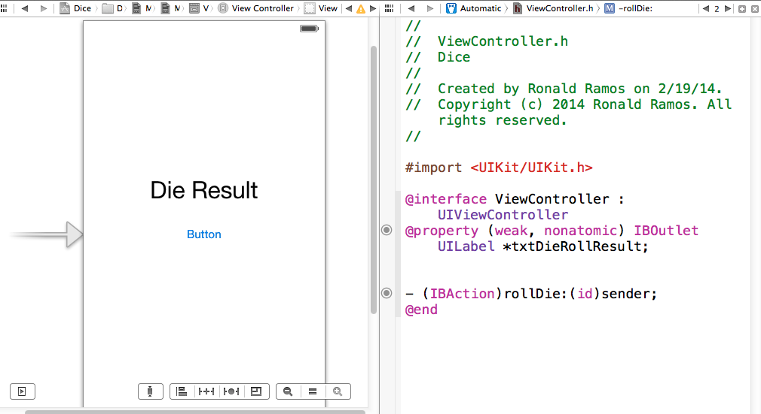

Given the interface and viewcontroller.h shown above complete the code needed. When a user presses the button the label will show a random number between 1 to 20 similar to a twenty sided die. Paste the code below (15 points):

HINT: This is the line of code to generate a 6-sided die being rolled 🡪 *int rollResult = (arc4random() % 20)+1;*

_________________________________

ESSAY:

**Answer at most 2 essay questions. Pasting answers directly from the internet will merit automatic failure. That is plagiarism.**

All essay answers must have at least 1 paragraph with at least 3 coherent sentences. Failure to follow this instruction will mean zero points in the essay.

1. What is objective-c? (10 points)
2. Explain ARC? (10 points)
3. What are the prerequisites for iOS app development? (5 points)
4. What is a story board in iOS app development? (10 points)
5. Can we develop without XCode? Why or why not? (10 points)
6. What was the last movie you saw? Did you like it? Why or why not? (5 points)
7. How has you iOS dev experience been so far? (5 points)

Rlramos2014