**DevProg MIDTERMS Set A**

School Year 2014-15 1st Term Ronald L. Ramos

NAME:______________________________________________

Year and Course:______________________________________

Student Number:______________________________________

Answer the questions below to the best of your ability. You have from 9am to 11am to answer this exam.

The exam is 100 points in total but you can go over 100 points depending on your answers

When done save the document as “DevProg MIDTERMS Set (A B or C) – Firstname Lastname.docx”. Upload the file to your wiki folder and update your wiki page.

Open notes. Open Eclipse. Open Internet. Closed Facebook, Twitter and Google+ and any other social media site.

**You cannot talk to anyone except ME during the duration of the exam. Anyone caught talking to a classmate/seatmate will automatically fail the exam.**

**You cannot use your cellphones during the duration of the exam. Please keep your phones in your bags or your pockets. Anyone caught looking at their phone will automatically fail in the exam.**

Goodluck and Godspeed!

1. When we create an Android project in Eclipse what type of application is created? (5 points)
2. After creating an Android project in Eclipse can we run the created project? (5 points)
3. Write the basic skeleton of an Activity class named PlayGameActivity (15 points)
4. Write the XML file for an Android Screen with a relative layout and a label control. (15 points)
5. Do we edit R.java? Why or why not? (10 points)
6. Given the android project below:

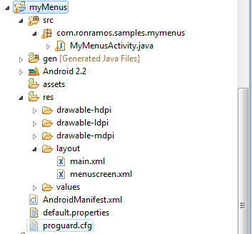

1. What is the project name? (5 pnts.) ______________________
2. How many Activities are in the project? (5 pnts) ____________
3. How many screens are in the application? (5 pnts) ___________________
4. What version of Android is the main target of this project?(5 pnts) _____
5. What is the name of the main activity class in this project? (5 pnts)______
6. (25 points) Write a small Android app that will convert temperatures back and forth from the Celsius and Fahrenheit temperature scales. The formulas for making the conversion are as follows:  
   Fahrenheit to Celsius: Cel s=(5/9)*(Fahr-32)  
   Celsius to Fahrenheit: Fahr =(9/5)*Cels+32  
     
   eg.: 68deg Fahr is 20deg Celsius  
     
   The User should be able to input a temperature, tell the app whether its C or F and then convert it.  
   Paste your code for the main activity class and main screen below

Bonus (Optional – each answer must have a minimum of one paragraph with at least 3 sentences per paragraph)

1. **(5 points)** Describe what R.java does for an Android application.
2. **(10 points)** What is an intent?

***Life comes down to honesty and doing what's right. That's what's most important.- Bob Feller***

***/rlrJuly2014 AMDG***.